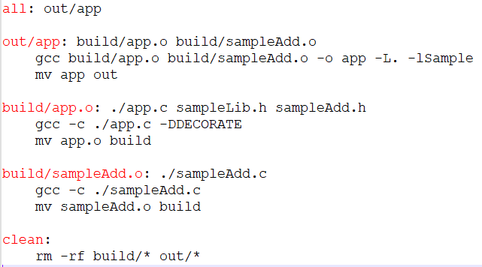

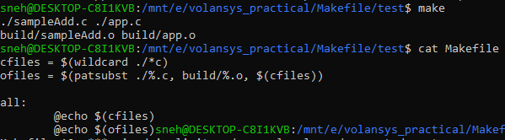

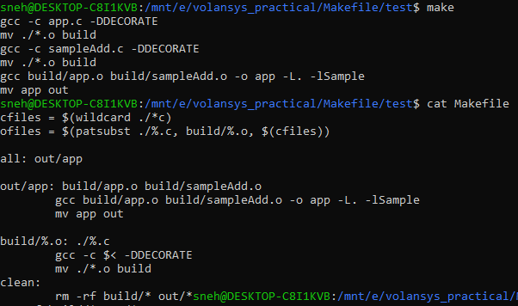

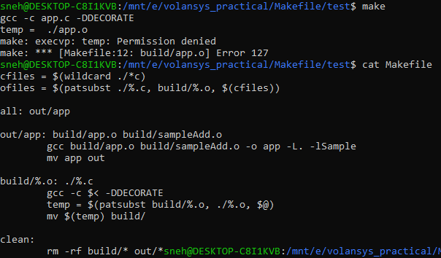

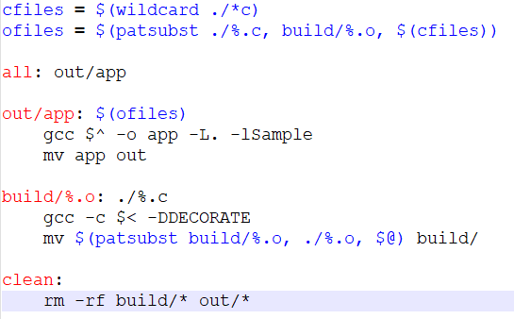

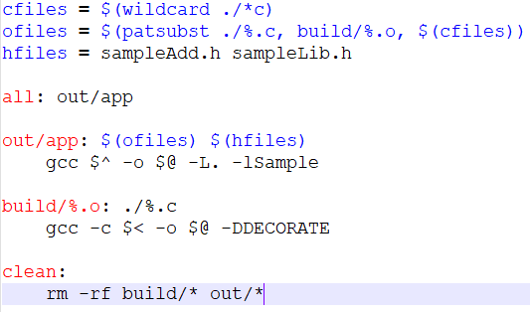

—------------------------------------------------------------------------------------------------------------

cfiles = $(wildcard ./\*.c)

ofiles = $(patsubst ./%.c, build/%.o, $(cfiles))

hfiles = sampleAdd.h sampleLib.h

denable = 1

dflag =

ifeq ($(denable), 1)

dflag += -DDECORATE

endif

all: out/app

out/app: $(ofiles)

gcc $^ -o $@ -L../Exercise3/ExtLib -lSample

out/app

build/%.o: ./%.c $(hfiles)

gcc -c $< -o $@ $(dflag)

clean:

rm -rf build/\* out/\*

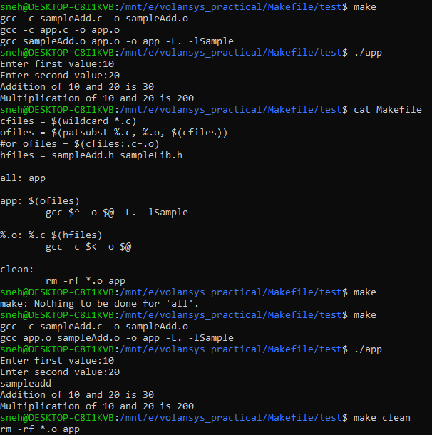

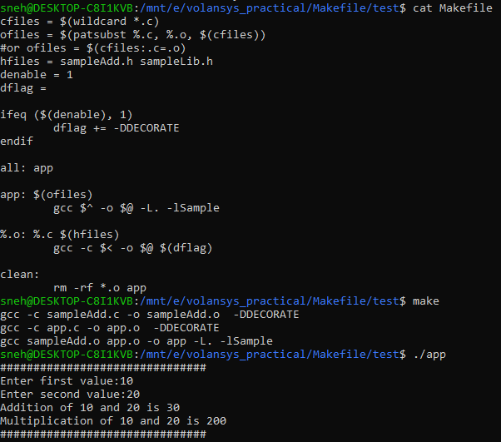

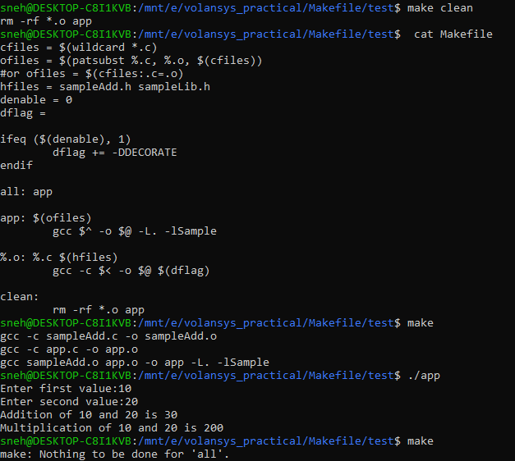

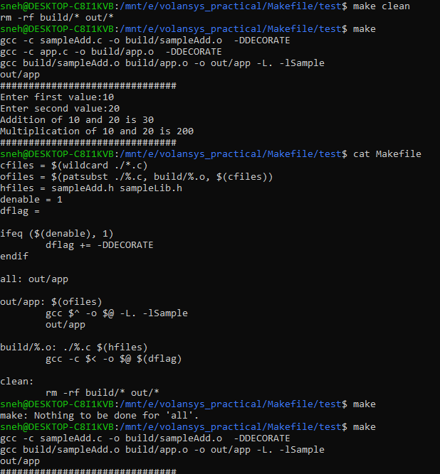

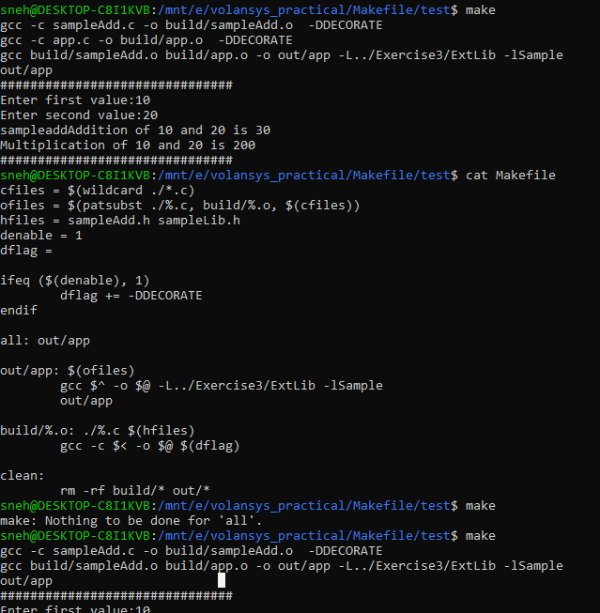

—------------------------------------------------------------------------------------------------------

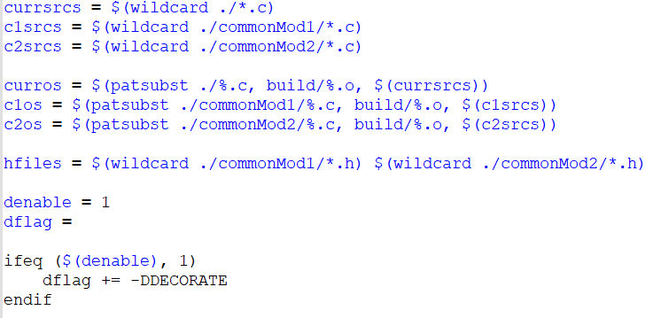

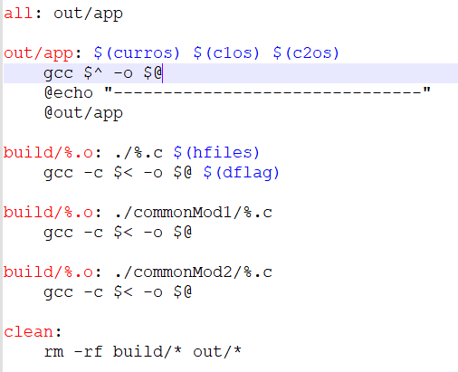

currsrcs = $(wildcard ./\*.c)

c1srcs = $(wildcard ./commonMod1/\*.c)

c2srcs = $(wildcard ./commonMod2/\*.c)

curros = $(patsubst ./%.c, build/%.o, $(currsrcs))

c1os = $(patsubst ./commonMod1/%.c, build/%.o, $(c1srcs))

c2os = $(patsubst ./commonMod2/%.c, build/%.o, $(c2srcs))

hfiles = $(wildcard ./commonMod1/\*.h) $(wildcard ./commonMod2/\*.h)

denable = 1

dflag =

ifeq ($(denable), 1)

dflag += -DDECORATE

endif

all: out/app

out/app: $(curros) $(c1os) $(c2os)

gcc $^ -o $@

@echo "-------------------------------"

@out/app

build/%.o: ./%.c $(hfiles)

gcc -c $< -o $@ $(dflag)

build/%.o: ./commonMod1/%.c

gcc -c $< -o $@

build/%.o: ./commonMod2/%.c

gcc -c $< -o $@

clean:

rm -rf build/\* out/\*

#include "./commonMod2/sampleDivide.h"

printf("Division of %d by %d is %d\r\n", a, b, sampleDivide(a, b));

int sampleDivide(int a, int b)

{

return (a/b);

}

int sampleDivide(int a, int b);